**PIZZA SALES SQL QUERIES**

**KPI’s**

**1. Total Revenue:**

SELECT SUM(total_price) AS Total_Revenue FROM pizza_sales;

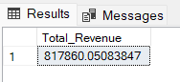

**2. Average Order Value**

SELECT (SUM(total_price) / COUNT(DISTINCT order_id)) AS Avg_order_Value FROM pizza_sales

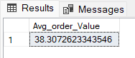

**3. Total Pizzas Sold**

SELECT SUM(quantity) AS Total_pizza_sold FROM pizza_sales

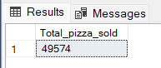

**4. Total Orders**

SELECT COUNT(DISTINCT order_id) AS Total_Orders FROM pizza_sales

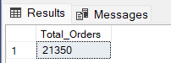

**5. Average Pizzas Per Order**

SELECT CAST(CAST(SUM(quantity) AS DECIMAL(10,2)) /

CAST(COUNT(DISTINCT order_id) AS DECIMAL(10,2)) AS DECIMAL(10,2))

AS Avg_Pizzas_per_order

FROM pizza_sales

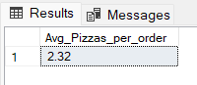

**Chart Requirements**

**NOTE:**

This Daily Trends and monthly trends have been done in Microsoft SQL server because date column was not getting converted into date format.

**Daily Trend for Total Orders**SELECT DATENAME(DW, order_date) AS order_day, COUNT(DISTINCT order_id) AS total_orders

FROM pizza_sales

GROUP BY DATENAME(DW, order_date)

***Output:***

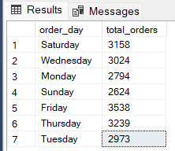

**Monthly Trend for Orders**

select DATENAME(MONTH, order_date) as Month_Name, COUNT(DISTINCT order_id) as Total_Orders

from pizza_sales

GROUP BY DATENAME(MONTH, order_date)

***Output***

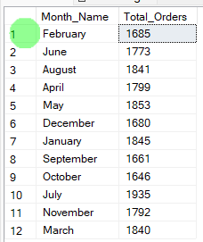

**% of Sales by Pizza Category**

SELECT pizza_category,

ROUND(SUM(total_price)) as total_sales,

CONCAT(ROUND(SUM(total_price) * 100 / (SELECT SUM(total_price) FROM pizza_sales),2),"%") as percentage_of_total

FROM pizza_sales

GROUP BY pizza_category;

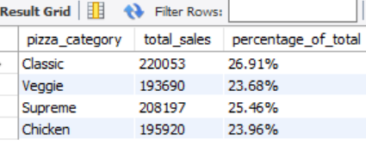

**% of Sales by Pizza Size**

SELECT pizza_size,

ROUND(SUM(total_price)) as total_sales,

CONCAT(ROUND(SUM(total_price) * 100 / (SELECT SUM(total_price) FROM pizza_sales),2),"%") as percentage_of_total

FROM pizza_sales

GROUP BY pizza_size;

ORDER By pizza_size;

***Output***

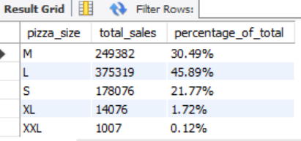

**Total Pizzas Sold by Pizza Category**

SELECT pizza_category, SUM(quantity) as Total_Quantity_Sold

FROM pizza_sales

WHERE MONTH(order_date) = 2

GROUP BY pizza_category

ORDER BY Total_Quantity_Sold DESC

***Output***

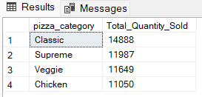

**Top 5 Pizzas by Revenue**

SELECT pizza_name,SUM(total_price) as Revenue FROM pizza_sales

GROUP BY pizza_name

ORDER BY Revenue DESC

LIMIT 5;

***Output***

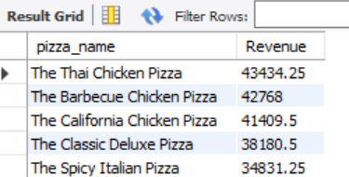

**Bottom 5 Pizzas by Revenue**

SELECT pizza_name, ROUND(SUM(total_price),2) AS Revenue FROM pizza_sales

GROUP BY pizza_name

ORDER BY Revenue ASC

LIMIT 5;

***Output***

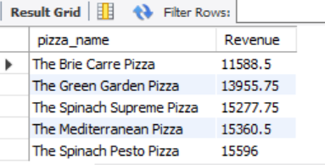

**Top 5 Pizzas by Quantity**

SELECT pizza_name, ROUND(SUM(quantity),2) as total_quantity FROM pizza_sales

GROUP BY pizza_name

ORDER BY total_quantity DESC

LIMIT 5;

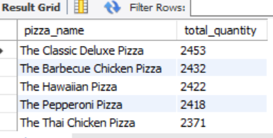

**Bottom 5 Pizzas by Quantity**

SELECT pizza_name, ROUND(SUM(quantity),2) AS total_quantity FROM pizza_sales

GROUP BY pizza_name

ORDER BY total_quantity ASC

LIMIT 5;

***Output***

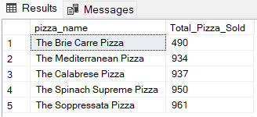

**Top 5 Pizzas by Total Orders**

SELECT pizza_name, COUNT(DISTINCT order_id) AS Total_Orders

FROM pizza_sales

GROUP BY pizza_name

ORDER BY Total_Orders DESC

LIMIT 5

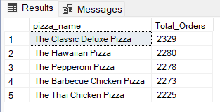

**Borrom 5 Pizzas by Total Orders**

SELECT pizza_name, COUNT(DISTINCT order_id) AS Total_Orders

FROM pizza_sales

GROUP BY pizza_name

ORDER BY Total_Orders ASC

LIMIT 5

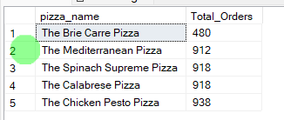

**NOTE**

If you want to apply the pizza_category or pizza_size filters to the above queries you can use WHERE clause. Follow some of below examples

SELECT pizza_name, COUNT(DISTINCT order_id) AS Total_Orders

FROM pizza_sales

WHERE pizza_category = 'Classic'

GROUP BY pizza_name

ORDER BY Total_Orders ASC

LIMIT 5